Lab 2 Screen shots

* Create a local git repository

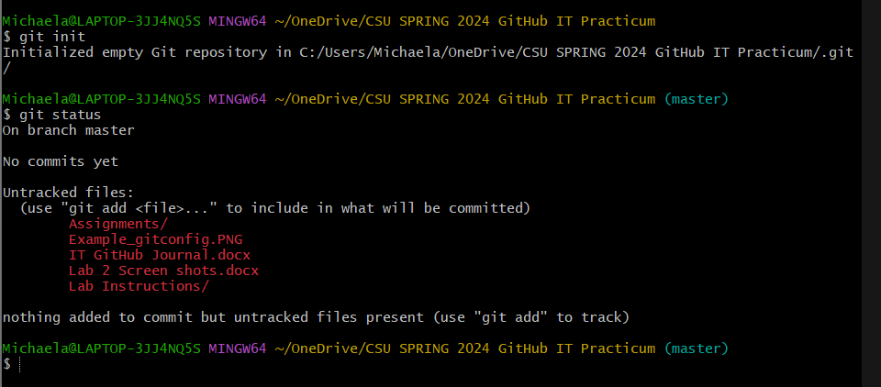

* Check status

* Add files to this repository

* Check status – screenshot 1
* Add files to stage for tracking
* Check status – screenshot 2
* Make first commit – add REQUIRED commit message
* Check status – screenshot 3
* Edit a file or two
* Check status – screenshot 4
* Add files to stage for tracking
* Check status – screenshot 5
* Make second commit – add REQUIRED commit message

Added files to stage for tracking